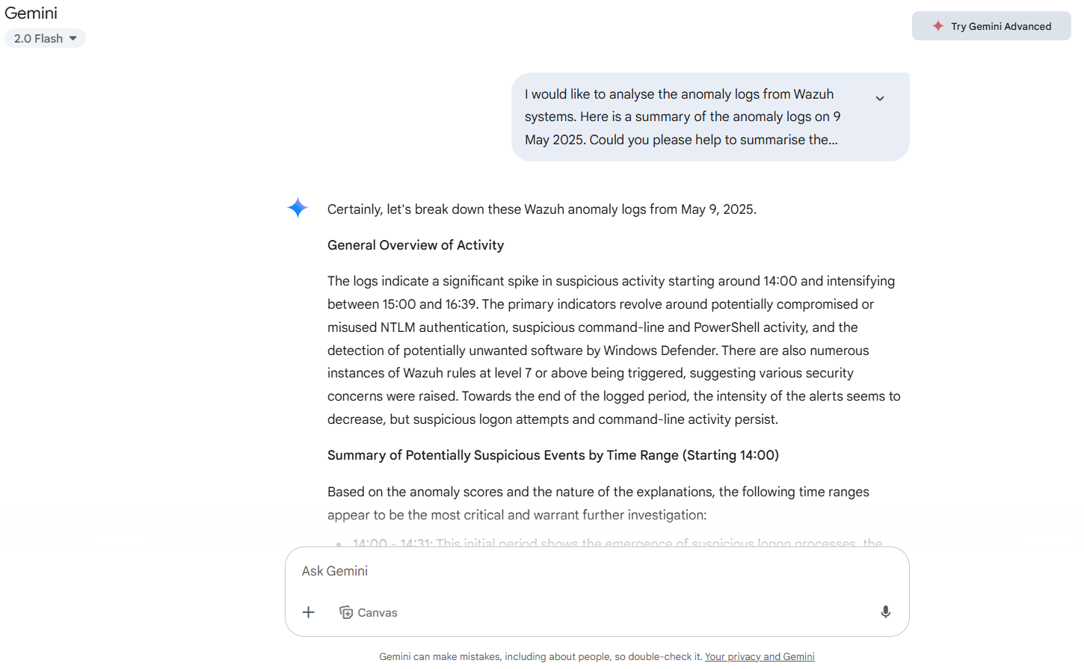
Certainly, let's break down these Wazuh anomaly logs from May 9, 2025.
General Overview of Activity
The logs indicate a significant spike in suspicious activity starting around 14:00 and intensifying between 15:00 and 16:39. The primary indicators revolve around potentially compromised or misused NTLM authentication, suspicious command-line and PowerShell activity, and the detection of potentially unwanted software by Windows Defender. There are also numerous instances of Wazuh rules at level 7 or above being triggered, suggesting various security concerns were raised. Towards the end of the logged period, the intensity of the alerts seems to decrease, but suspicious logon attempts and command-line activity persist.
Summary of Potentially Suspicious Events by Time Range (Starting 14:00)
Based on the anomaly scores and the nature of the explanations, the following time ranges appear to be the most critical and warrant further investigation:
- 14:00 - 14:31: This initial period shows the emergence of suspicious logon processes, the execution of commands via the command prompt by suspicious processes, and PowerShell being used to delete files. The triggering of Wazuh rules at a medium to high severity level during this time further emphasizes the potential severity.
- 14:58 - 15:19: While there are some isolated medium/high severity Wazuh rule triggers, the activity escalates significantly around 15:07. This timeframe is dominated by repeated alerts of potential NTLM relay attacks and pass-the-hash logins, often accompanied by suspicious logon processes and the assignment of special privileges. Notably, Windows Defender starts detecting and blocking potential threats within this period.
- 15:24 - 15:31: This short burst of activity shows a concerning progression. Alongside the continued NTLM-related anomalies, we see indicators of a binary being placed in a malware-prone directory, suspicious PowerShell scripts being executed, and ultimately, a binary being dropped in the Users\Public directory after a web request download cradle and PowerShell archive expansion. The anomaly score of 118 at 15:31 is exceptionally high and demands immediate attention.
- 15:35 - 16:39: This extended period continues to show high anomaly scores, primarily driven by persistent NTLM-related suspicious activities. Additionally, there are alerts regarding command-line execution from unusual parent processes, remote execution via net.exe, PowerShell querying environment variables, and even reconfiguration of a Windows installer product. Towards the later part of this range (around 16:15 onwards), there's a resurgence of very high anomaly scores, accompanied by indicators of binaries being dropped in the Windows root directory and the creation of new suspicious Windows services. The repeated occurrence of these high-scoring events suggests a sustained and potentially automated malicious activity.
In summary, May 9, 2025, saw a significant security event unfold, characterized by suspicious authentication attempts, command execution, potential malware deployment, and Windows Defender actively responding to threats. The timeframes between 15:00 and 16:39 appear to be particularly critical and should be the focus of your immediate analysis.

